**Description**

As a user, if I do not have an account with Money Tree, I should be able to hit the Register button from the sign in page, and be directed to a new page where I see a form to fill out personal information. I should be able to see the tamagotchi at the top before I fill in the personal information.

------------------------------------------------------------------------------------------------------------------------------------------

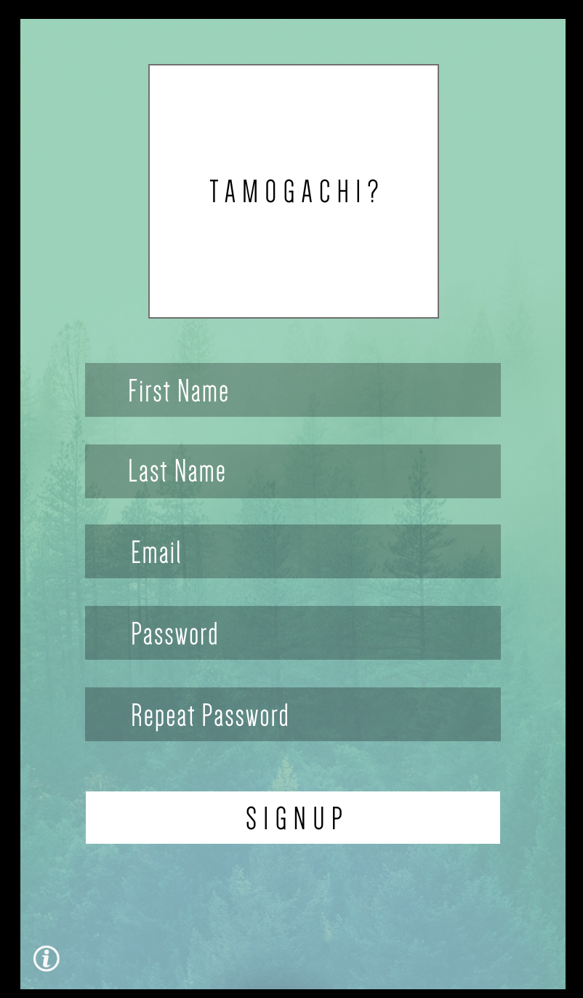

**Acceptance criteria**

* Display tamagotchi with options to customize appearance
* Display an input box for First Name – Allow Characters, Not numbers
* Display an input box for Last Name – Allow Characters, Not Numbers
* Display an Input box for Email Adress – Must be Valid
* Display an input box for Password – Need to be 8 letters? (Idk)
* Display an input box to Confirm Password. – Need to make sure repeated password and entered password in the box above match
* Display a save button where user can click when completed and be directed to the next page.
* Information should be stored in Database